Assignment: Master-Detail Relationship
- Create two custom objects: Object A and Object B.
- Add a few records to both objects.
- Try to create a Master-Detail Relationship on Object B with Object A as the master object.
- Observe the error that Salesforce displays.
Question:
- What error did you encounter?
The following error occurred:
Cannot Create Master-Detail Relationship
You cannot create a new Master-Detail relationship on an existing custom object if records already exist. You must first create a Lookup relationship, populate the lookup field with data in all records, and then change the relationship type to Master-Detail.
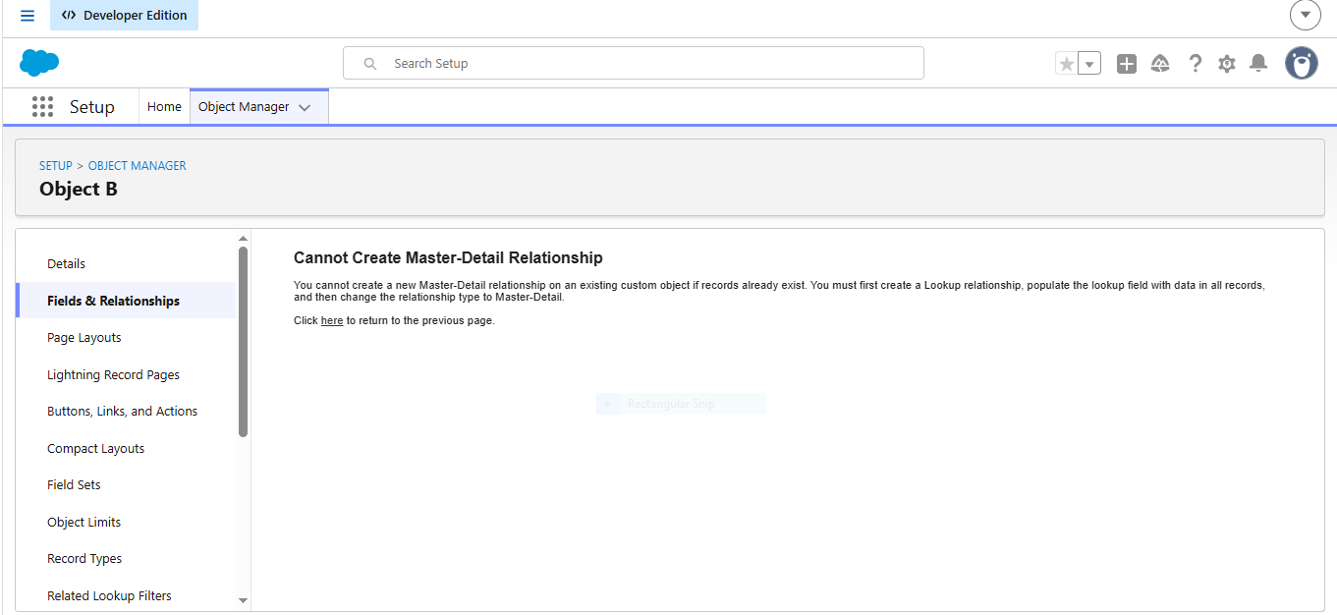
- Why did this error occur?
The error occurs because Salesforce enforces strict data integrity rules on Master-Detail relationships, which dictate that every detail (child) record must always be linked to a valid master (parent) record. When a Master-Detail field is created, the system makes that relationship field strictly mandatory across the entire database table. Because Object B already contains existing records, attempting to add a new Master-Detail field creates a data conflict; these existing records would instantly possess a blank parent field, which violates the database schema. To prevent these illegal, orphaned child records from being generated, Salesforce proactively blocks the field creation and displays the error message.
- How can you resolve the error and successfully create the Master-Detail relationship?
To successfully resolve this error and create the relationship, you must ensure that no child records are left without an assigned parent during configuration, which can be accomplished using two distinct approaches. The standard business best practice is the Lookup Conversion method, where you first create a lenient Lookup relationship field between Object B and Object A since lookups allow empty values. You then navigate to your existing Object B records to manually populate that new lookup field with a valid Object A parent for every single entry. Once every record is fully updated, you return to the Object Manager, edit the field configuration, and use the "Change Field Type" utility to safely convert the Lookup field into a Master-Detail relationship. Alternatively, if the existing records are merely disposable test data, you can simply delete all records from Object B, permanently purge them from the Recycle Bin, and then build the Master-Detail field directly on the empty object without triggering any system conflicts.

